Step 1) Enable 1st and 3rd one’s. And Save the changes  
  
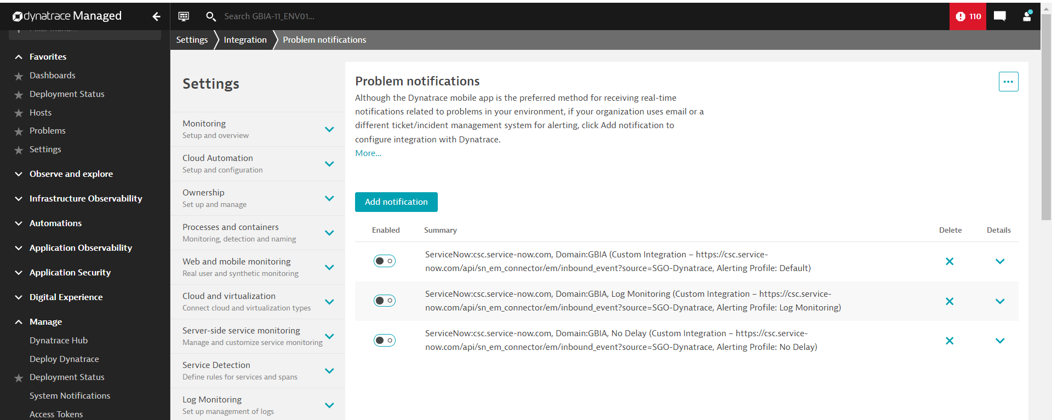

Step 2) Go to Hosts => Select Any Host  
  
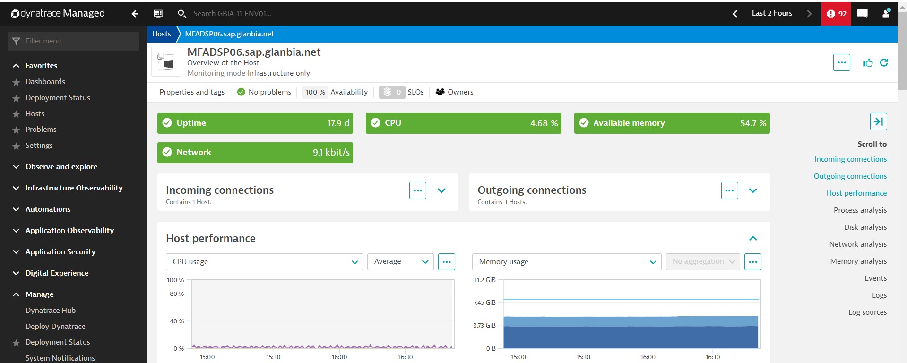

Step 3) Click on 3 dots and select settings.

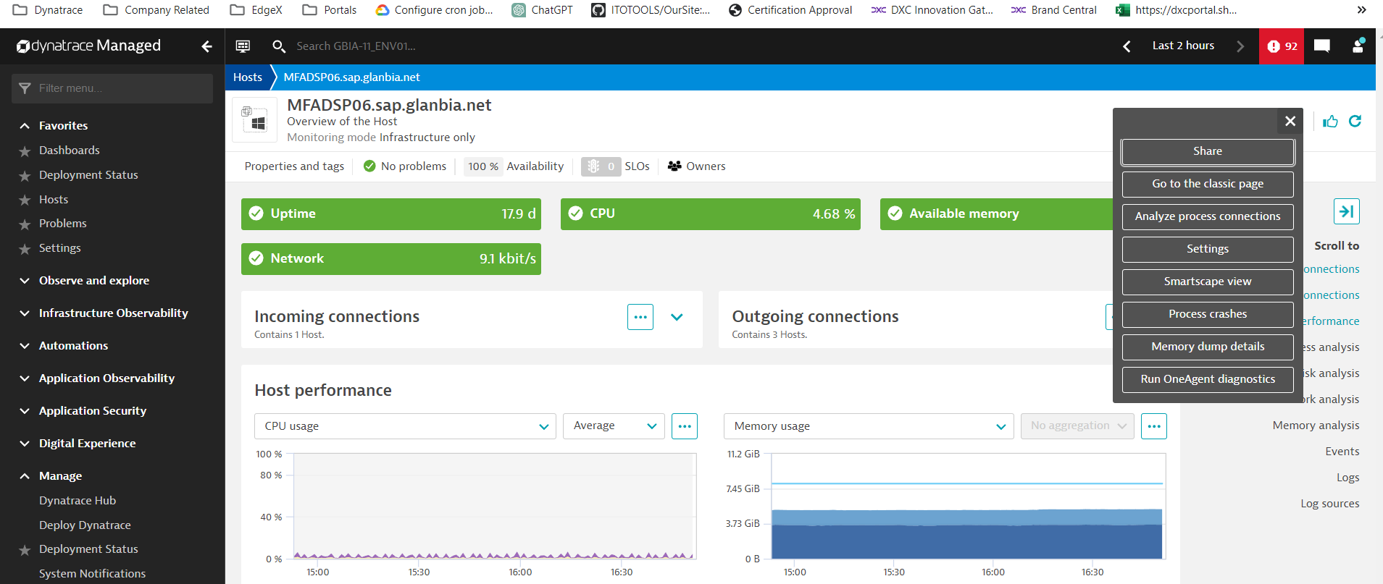

Step 4) Under Anomaly Detection select Disks.

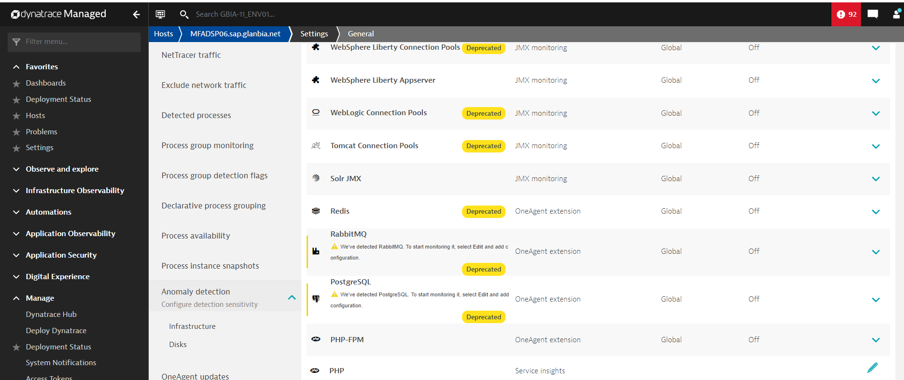

Step 5) Select the specific drive.

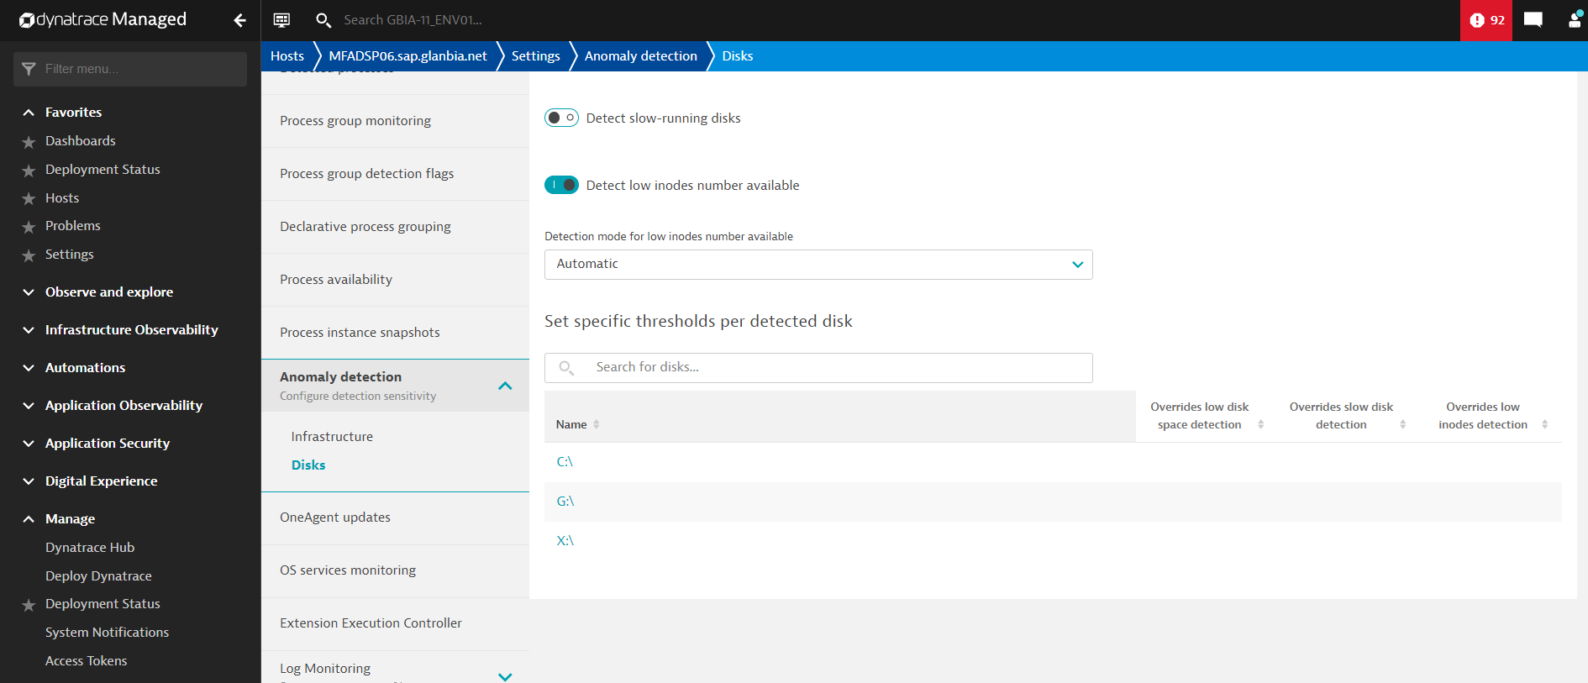

Step 6) Enable Override low disk space detection settings and set detection mode to based on custom settings.

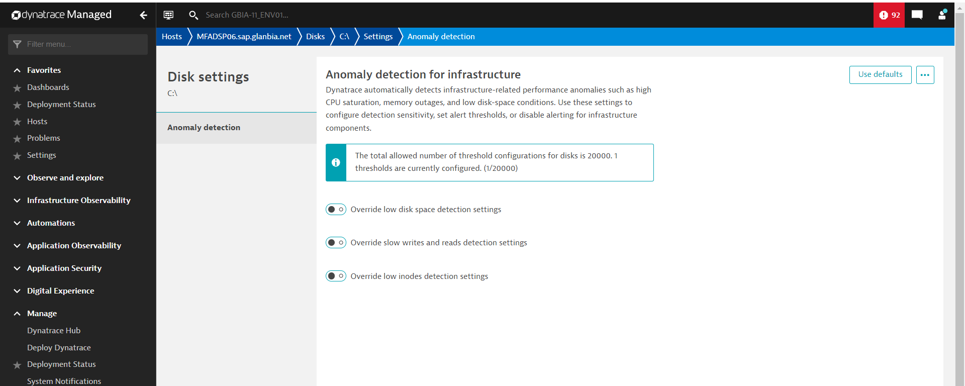

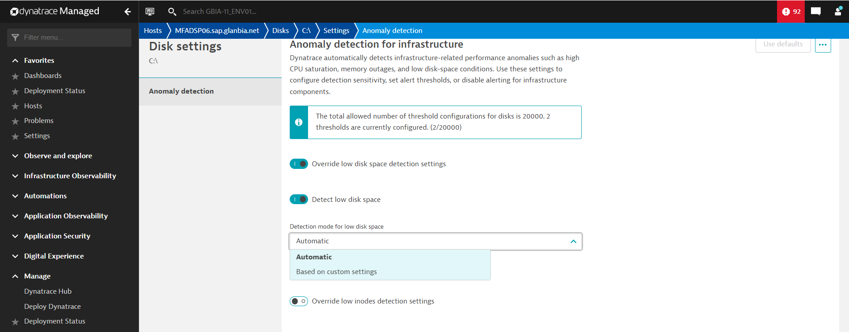

Step 7) Set to 99% and Save Changes.

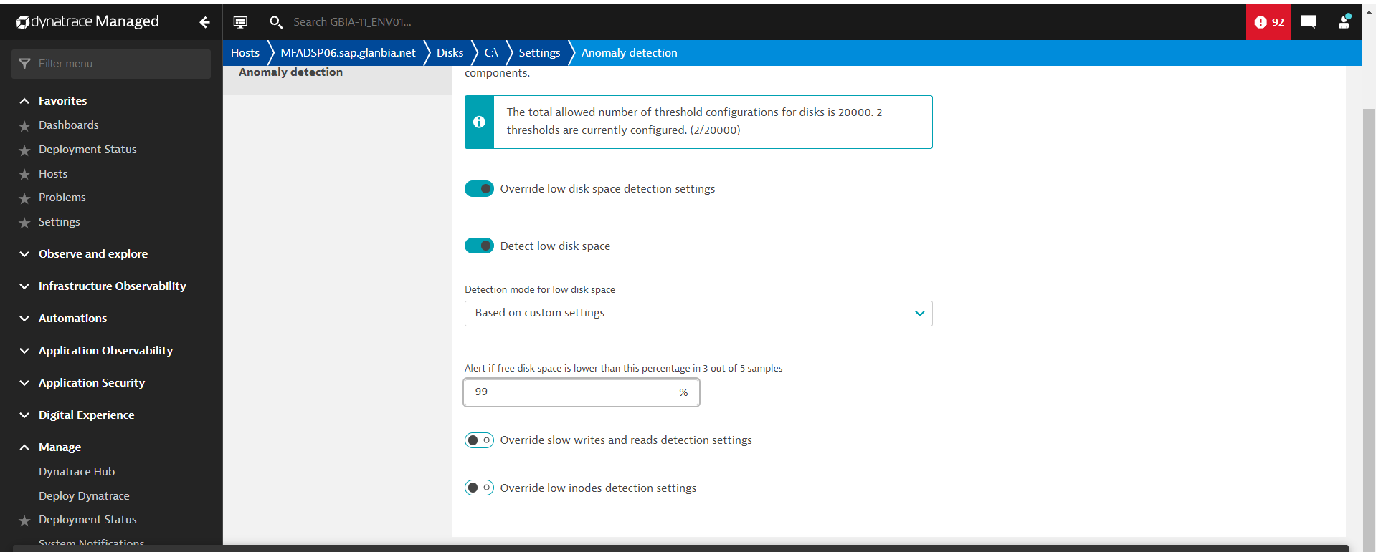

After 35 Minutes the Incident will be created on **ServiceNow.**